ShopSmart Test Runs

## Load Test Run

### Parameters

Number of concurrent users: 8

Period of run: 10 mins

Achieved throughput: 100065 requests in 10 mins

Average throughput: ~166 requests/sec

### Reports

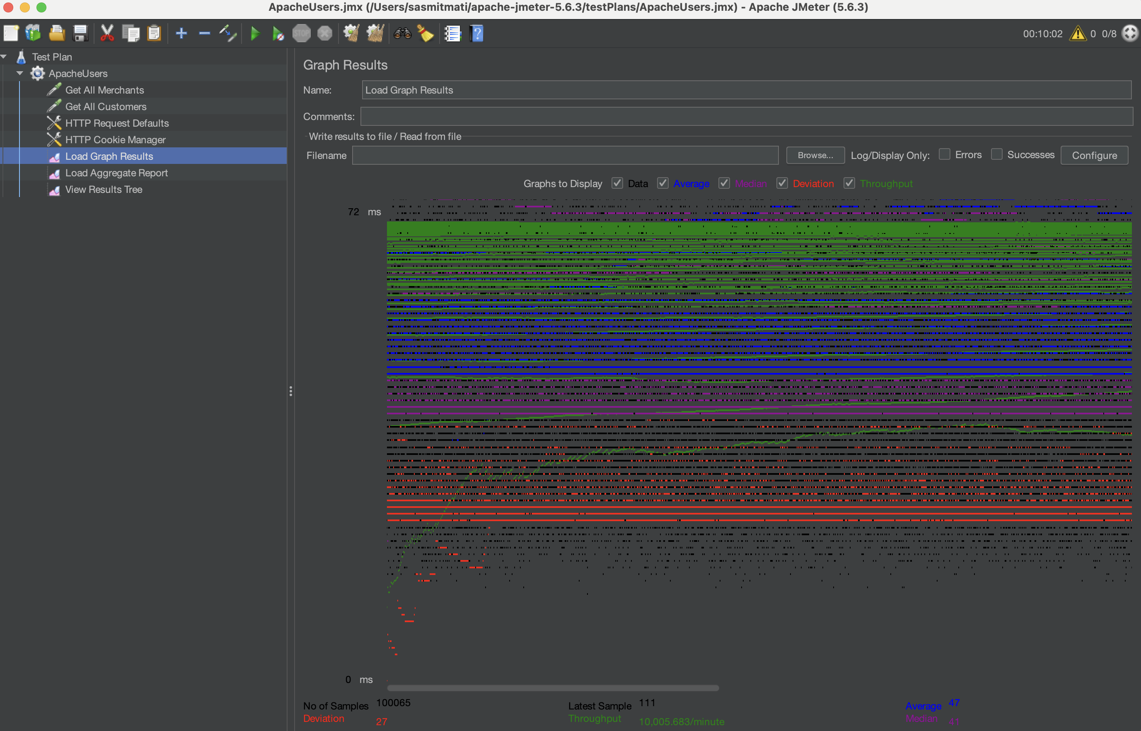

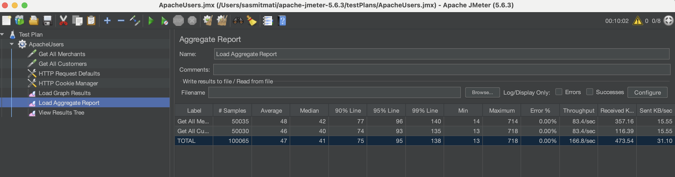

## Stress Test Run

### Parameters

Number of concurrent users: 20

Period of run: 10 mins

Achieved throughput: 119745 requests in 10 mins

Average throughput: ~200 requests/sec

### Reports

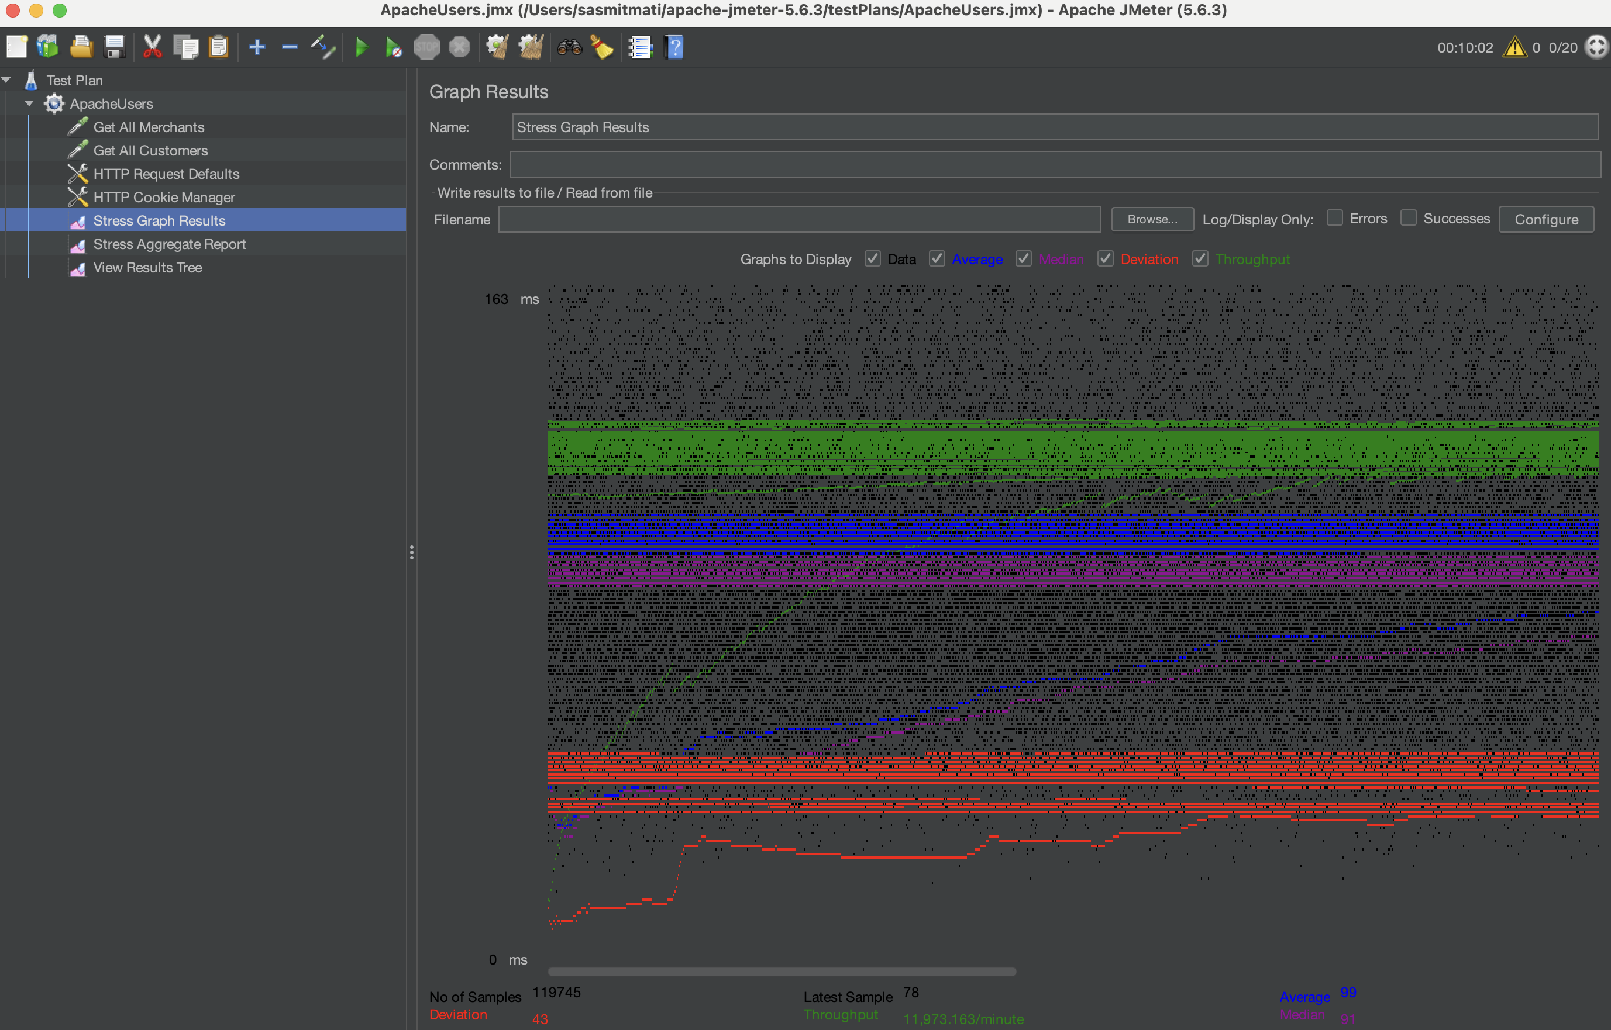

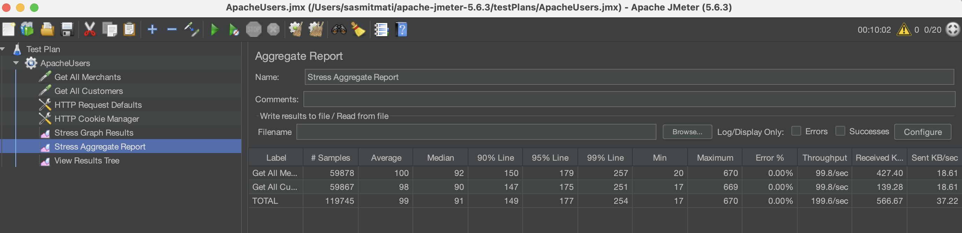

### Additional insights

We ran additional stress tests:

1. 12 Concurrent users -> ~170 requests / sec
2. 16 Concurrent users -> ~180 requests / sec
3. 20 Concurrent users -> ~200 requests / sec
4. 24 Concurrent users -> ~182 requests / sec

## Soak Test Run

### Parameters

Number of concurrent users: 12

Period of run: 60 mins

Achieved throughput: 612540 requests in 60 mins

Average throughput: ~170 requests/sec

### Reports

